**PROGRAM:99**

**package** shazia;

**import** java.util.regex.*;

**class** RegexExample7{

**public** **static** **void** main(String args[]){

System.***out***.println("by character classes and quantifiers ...");

System.***out***.println(Pattern.*matches*("[789]{1}[0-9]{9}", "9953038949"));//true

System.***out***.println(Pattern.*matches*("[789][0-9]{9}", "9953038949"));//true

System.***out***.println(Pattern.*matches*("[789][0-9]{9}", "99530389490"));//false (11 characters)

System.***out***.println(Pattern.*matches*("[789][0-9]{9}", "6953038949"));//false (starts from 6)

System.***out***.println(Pattern.*matches*("[789][0-9]{9}", "8853038949"));//true

System.***out***.println("by metacharacters ...");

System.***out***.println(Pattern.*matches*("[789]{1}\\d{9}", "8853038949"));//true

System.***out***.println(Pattern.*matches*("[789]{1}\\d{9}", "3853038949"));//false (starts from 3)

}}

**OUTPUT:**

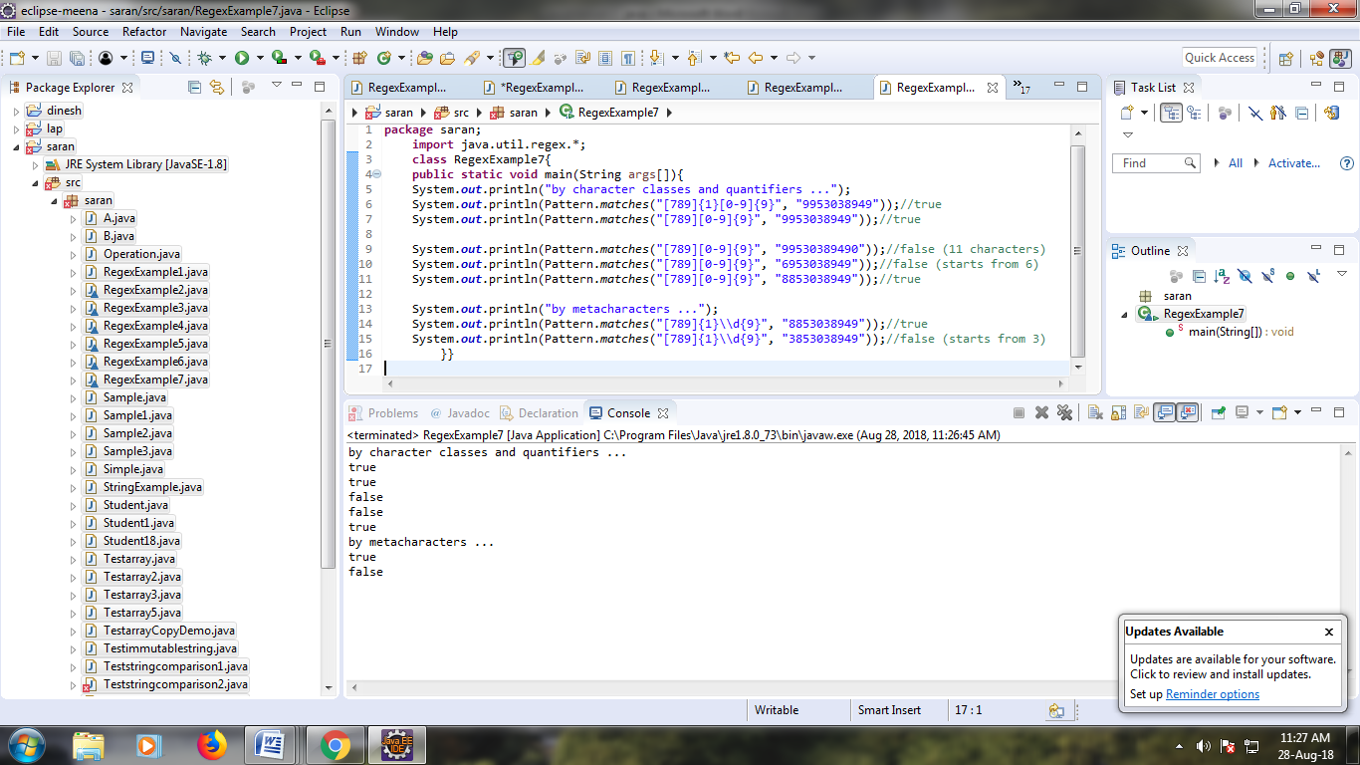

**PROGRAM:100**

**package** shazia;

**public** **class** Testtrycatch2 {

**public** **static** **void** main(String args[]){

**try**{

**int** data=50/0;

}**catch**(ArithmeticException e){System.***out***.println(e);}

System.***out***.println("rest of the code...");

}

}

**OUTPUT:**

